March 24, 2023 – Java Project – Thea Gregory 5291240

Today I worked on the following:

* Created a restaurant class
* Created edit restaurant view
* Created edit restaurant model
* Began edit restaurant controller
* Completed add new restaurant with successful insertion into DB (last night)

Today went very well. I found a way to accelerate making views so I don’t waste time on minute details, that way I can focus more on the code. I created the restaurant class so I can make the function that populated the edit view. My next step is to have the edit restaurant form load from clicking on the restaurant name in the JTable I inserted onto the view. I am hoping that only a small amount of research will be needed to make that work as I have what’s needed for the rest. I didn’t encounter many issues today, as I have become used to working with MVC and know how it works now. I should have edit and delete finished by the end of tonight, leaving me the weekend to advance even further with less complex use cases.

Screenshots:

Portion of edit view with JTable included:

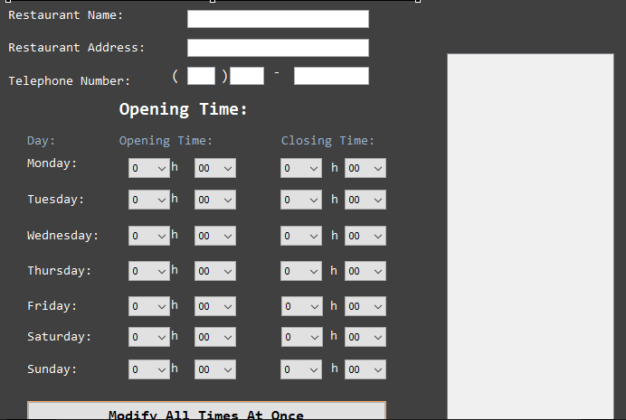

A sample of the Restaurant class. Includes the constructor:

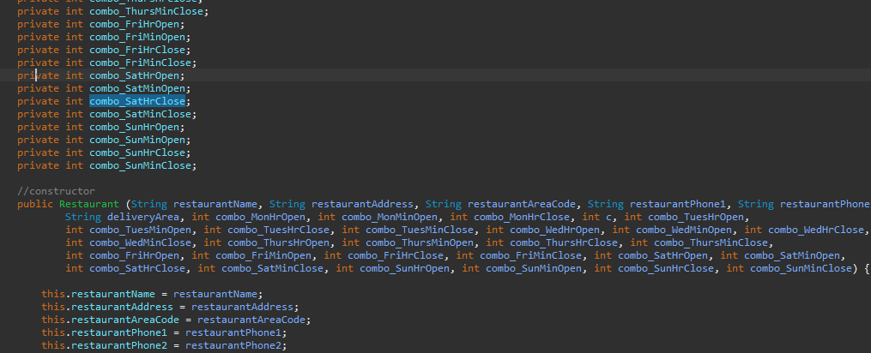

The model with the first validation function included for reference:

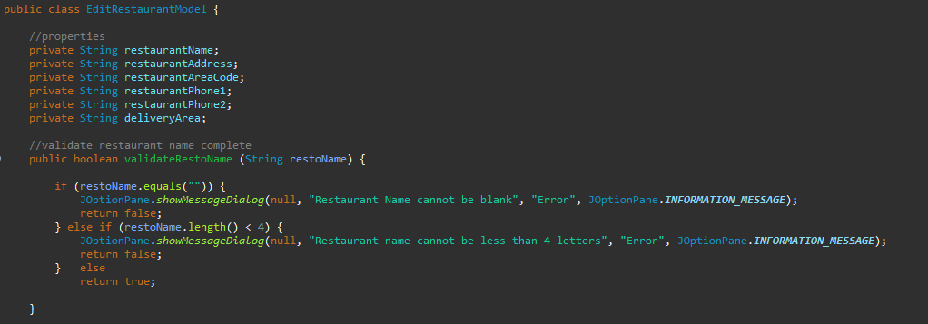

The beginning of the controller:

